A huge welcome back to you all after the break. I hope you all managed to spend time with family and loved ones. The children have returned to school with lots of enthusiasm and excitement about their learning and have been really engaged during the launch days. We have lots to look forward to in our learning this term, all of which is outlined below. As always, if you have any queries or concerns, please don’t hesitate to get in touch. Thank you so much.
Year 5 Summer Newsletter 2026

English
Linked to our theme of Power and communication, our class text this term is the King Who Banned the Dark by Emily Howarth-Booth. It is a beautiful picture book which tells a tale of Power, rebellion, darkness and light with a number of themes running through that are relevant to society today. Using the text as a stimulus, children will be learning how to write an effective newspaper report whilst gaining an understanding why you can’t always believe what you read. Children will also be learning to write a problem and resolution narrative where they will apply a variety of writing skills. The children have already enjoyed exploring the book through art, investigating the vocabulary used within the text and developing their oracy skills through drama and role play.

Maths
In maths this term we will be learning about the properties of shape, including angles, and how to draw and measure them before moving on to position of shapes. We will use these skills to solve a variety of problems and have plenty of opportunities to apply our learning to real life situations. We will also revisit our work on fractions, decimals and percentages. In order to further support learning, please can you ensure children are accessing linked maths activities on Mathletics. This is a fantastic resource which reinforces the learning taking place in the classroom and it would be great to see year 5 achieve even more certificates and gain first place on the leaderboard!

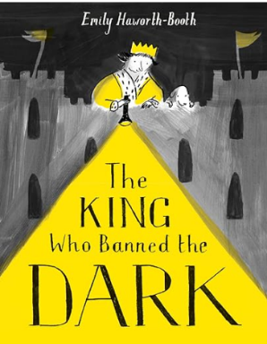
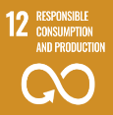
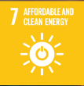
PE
This term, PE will continue to take place on Tuesdays where we will be learning the skills required in athletics. Please ensure that your child arrives to school in the correct school PE kit, every Tuesday.
As usual, they will continue to take part in Yoga lessons on Thursdays (PE kit is not required for Yoga.)

Topic
Our theme for this term is Power and Communication. Thank you so much to those children who created some really fantastic holiday homework and who clearly put so much time and thought into it. Through this theme, we will be focusing on Geography, exploring the importance of Rivers on trade and the economy. In addition to this, we will learn how settlements have changed and developed over time. We will also compare some major cities across the world and how Rivers have impacted their development.

Homework
Homework will continue to be set and Monday and will be due in the following Monday. Children will receive the spelling and reading homework in their purple books and maths will be set on Mathletics.

All children are expected to complete their homework as it is an extension of their learning in school.

Science
In science we will be learning about forces and the work of Isaac Newton. They will explore how forces are constantly in action around us. In addition to this, they will continue to develop their skills as a scientist, by conducting investigations, making observations and categorising.

Sustainable development Goals.

Throughout the term we will be looking at how we can help the world achieve the UN’s SDGs. This term we will focus on goals 7 and 12. We will reflect on how our learning can have an impact on the wider world.

