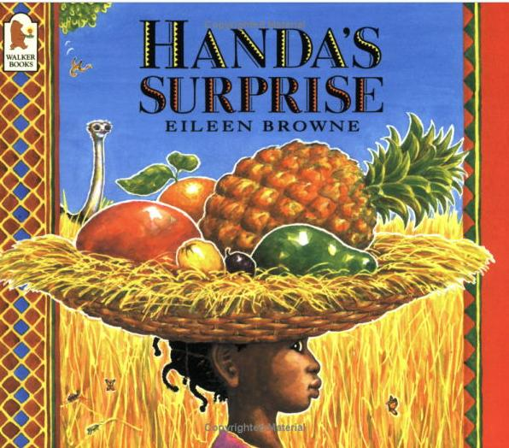
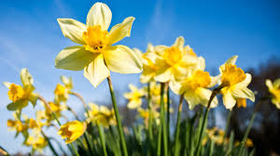
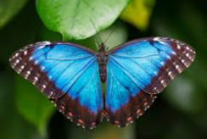

Reception
Summer Newsletter

Showbie: Please ensure that you are logged in and regularly accessing your child’s Showbie account to ensure you are up to date with school information.
Reading Diaries - Please ensure you read with your child every day and sign your child’s reading diary.

Literacy and Phonics
In our phonics lessons we are continuing to work on phase 3 of our phonic programme Essential Letters and Sounds. We encourage the children to read and write a range of words and sentences.
The children have been learning key facts in their sentence writing; that we start from the left of the page, we use finger spaces, and each sentence starts with an upper case letter and ends with a full stop.

Encourage your child to practise writing a short sentence at home.
Can they write them in a letterjoin script?
You can practise this at: www.letterjoin.co.uk
Username: lj6682 Password: home

Yoga | Thursday
PE | Friday
Please ensure that your child comes to school every Friday dressed in their Edna G. Olds PE kit – a red top and black trousers/ shorts.
Maths
In Maths this term we will be exploring numbers beyond 10. We will be counting, learning to form the numerals, and understanding that a number can be ten and a bit more. We will continue to use practical resources to help us and learn through play.
Through small group and practical activities, we shall also be learning to recall the pairs of numbers that total ten.

This half term our topic is ‘Power and Communication’. We will be exploring how we communicate with one another and we also look at how plants and mini beasts change and grow. We shall explore how our local and school environment is changing as we move into spring.
Our class book is ‘Handa’s Surprise’ by Eileen Browne. Through the story we will be learning the names of new fruits and even get to taste them! We will sequence the story and act out parts of it to perform to the class. We will also compare the location of Kenya with Nottingham, exploring different animals and the weather.

