Welcome Back!
The children have come back to school with great enthusiasm after a restful break. We are really looking forward to some exciting learning opportunities over the term!
Nursery
Summer Term Newsletter

This half term our topic is ‘Power and Communication’. We will be exploring this theme through nature and how powerful growth and change can be. We will be learning about the life cycle of a butterfly and how caterpillars transform over time. We will be exploring the story ‘The Very Hungry Caterpillar’ to support our understanding of this which will give us lots of great opportunities for storytelling!
We also look forward to growing our understanding of Spring and Summer and what changes happen over this time. Lots of our activities in the classroom and outdoors will be centred around nature and these seasons.

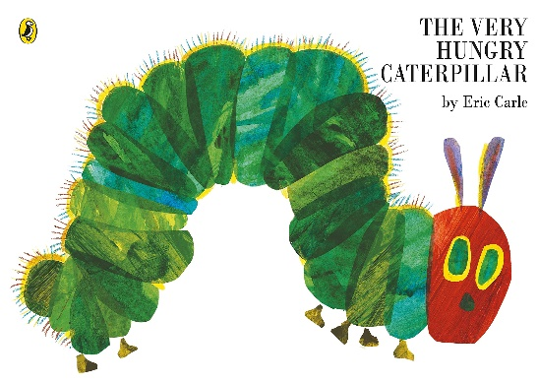

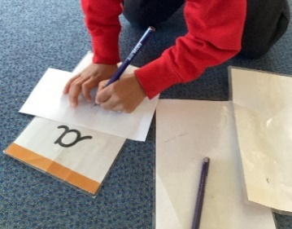
Maths
Through daily maths group times, carpet time activities, and during their play the children will be exploring number, shape and pattern.
We will be looking at quantities up to five and exploring one more and one less than these numbers. The children will have lots of opportunities to use objects to count with and explore these concepts. We will also practice our use of the language ‘more’ and ‘fewer’ to describe amounts.
We will move on to explore 2D and 3D shapes and identifying them by looking at their properties and comparing what they look like. The children will be supported to use language such as sides, corners, faces and flat.
During our work around pattern we will be looking at repeating patterns in different sequences and continuing these patterns independently. The children will be creating patterns of movement and with objects to explore this further.

Literacy and Phonics
In our Phonics groups we are continuing to build on our listening and attention skills.
We will be continuing to practice our oral segmenting and blending skills, listening carefully for the sounds we can hear in words and at the beginning of words.

We will be continuing to work on identifying initial sounds in words, using the ELS phonics scheme to do this. The children take part in daily phonics sessions to explore one letter sound per week, using our special phonics bag and different characters to help us.

If you would like more information around phonics in Nursery please don’t hesitate to ask!

