Topic
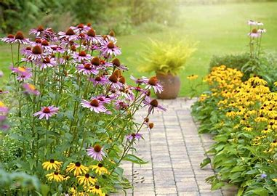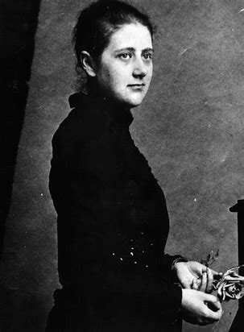

PE
The children’s PE lesson will be every Monday. This half term we will be doing athletics. Please remember to send your child to school wearing their PE kit on this day. The school PE uniform consists of a red top and black trousers/shorts. In addition, we have a yoga lesson every Thursday morning and a mile run session every Thursday afternoon.

Thank you for your continued support, Miss Muggeridge and Mr Bullock.

Homework
The children are set homework each week as follows:
Wednesday: Reading / comprehension homework will be set on Oxford Owl ELS. Maths homework will be set on Mathletics. These should both be completed by the Tuesday.
Wednesday: Handwriting / spelling homework will be sent home in the purple books. This should be returned by the following Tuesday.
There will also be a piece of holiday homework to be completed before the start of each half term. Details to follow towards the end of the half term.

English
This term, we will continue to develop our spelling skills and use of capital letters and punctuation. We will also continue to write more and add details to our writing. Our class book this half term is ‘The Gift of the Sun’ by Dianne Stewart and Jude Daly. We will be using a range of outdoor learning and drama to support our creativity and writing of a recount and a set of instructions linked to this text.

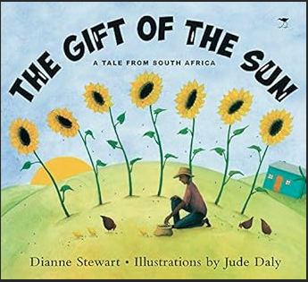
Maths
In Maths, Year 1 will be representing, comparing and ordering numbers up to 100. They will also begin to learn about multiplication and division, fractions and time. In year 1, your child is expected to learn their 2, 5 and 10 times tables. Therefore, it is crucial that they are encouraged and supported at home to practise their times tables. All children have access to Numbots to support with this.

Welcome to the Summer term at Edna G. Olds Academy. The children have made such brilliant progress throughout the year and we are so looking forward to the Summer term learning.
Year 1 Summer Newsletter 2026

