Welcome to the Summer term at Edna G. Olds Academy. The children have made a fantastic start to the new term. Across the school, our core value focus this term is on creativity and motivation.
Year 6 Summer Newsletter 2026

Maths
In preparation for SATS, we will be revising key mathematical concepts in order to explore multi-step problem solving questions. All children will have an opportunity to collaborate with peers in order to solve real-life problems, further deepen their understanding and refine key skills.
English
Our class author this half term is Lemony Snicket who wrote ‘The Dark’. This term, we will use the illustrations and language of our new class book to support our fiction and non-fiction writing. In addition, we will focus on confidently constructing a range of complex sentences using different grammatical features. To support our learning, we will be using a range of outdoor learning, art, drama and multimedia to inspire and capture their creativity. Our class novel this term is called ‘The Girl of Ink and Stars’ by Kiran Millwood Hargrave.

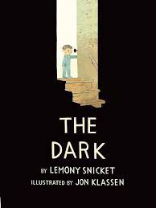
Topic

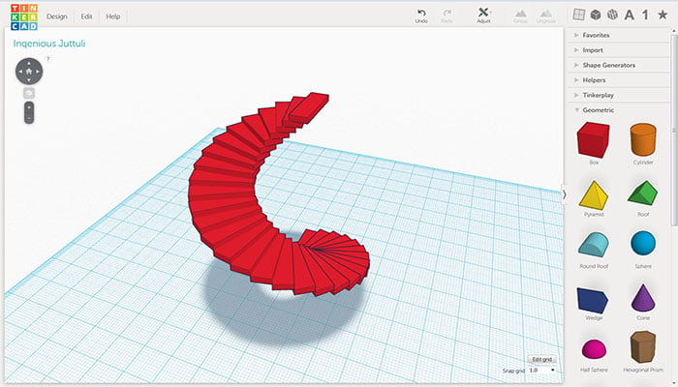

This Summer term, our enquiry-based curriculum will focus on the themes of Power and Communication. In Science, we will build on our prior knowledge of light by conducting scientific enquiries to investigate how light appears to travel in a straight line and how objects reflect light into our eyes. In History, we will explore the discoveries of Ole Rømer and examine why he is considered an important historical figure. In Computing, Year 6 will be learning about 3D modelling, including how to modify, rotate, and duplicate objects.

PE
The children’s PE lesson will be every Monday afternoon. Your child must come to school wearing their PE kit. The school PE uniform consists of a red top and black trousers/shorts. In addition, we have a yoga lesson and a mile run every Thursday afternoon. On this day, children should come to school with a pair of trainers to change into for the mile run.

Summer 1: Athletics

Summer 2: Cricket


Homework
Homework will be set every Monday (mathematics, comprehension and spellings) and children will have one week to complete it.
Comprehension homework - Students will be assigned weekly comprehension tasks to enhance their reading and understanding skills. This will be sent home in a comprehension book.
Spelling homework - Weekly spelling activities will be assigned to help students improve their vocabulary and spelling accuracy. This will be sent home in a spelling book.
Mathletics - Students will continue to complete their mathematics homework through the Mathletics platform.
These assignments are designed to support students’ learning and ensure they are well-prepared for the challenges of secondary education.
It is important that children are encouraged to complete their homework regularly, as this is an extension of their learning at school.

Your child’s login and passwords can be found in their homework diary.

